UNIT-III
REQUIREMENTS ENGINEERING PROCESS
- The goal of the requirements engineering process is to create and maintain a system requirements document.
- The overall process includes four high-level requirements engineering sub-processes.
- These are concerned with assessing whether the system is useful to the business (feasibility study);
- discovering requirements (elicitation and analysis);
- converting these requirements into some standard form (specification);
- and checking that the requirements actually define the system that the customer wants (validation).
- Figure 7.1 illustrates the relationship between these activities. It also shows the documents produced at each stage of the requirements engineering process.
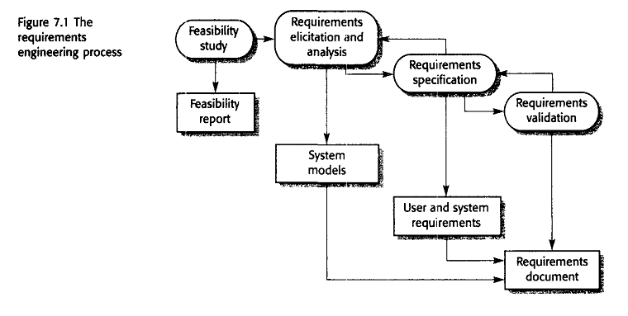
Feasibility studies
- For all new systems, the requirements engineering process should start with a feasibility study. The input to the feasibility study is a set of preliminary business requirements, an outline description of the system and how the system is intended to support business processes.
- The results of the feasibility study should be a report that recommends whether or not it is worth carrying on with the requirements engineering and system development process
- Technical feasibility: It is carried out to determine whether the company has the capability in terms of software, hardware&personnel expertise to handle completion of project.
- Economic feasibility: I f benefits outweigh costs then decision is made to implement.
- Operational feasibility: How well a proposed system solves problems?
- In a feasibility study, you may consult information sources such as the managers of the departments where the system will be used, software engineers who are familiar with the type of system that is proposed, technology experts and end-users of the system. Normally, you should try to complete a feasibility study in two or three weeks.
Requirements elicitation and analysis
- The next stage of the requirements engineering process is requirements elicitation and analysis. In this activity, software engineers work with customers and system end-users to find out about the application domain, what services the system should provide, the required performance of the system, hardware constraints, and so on.
- Requirements elicitation and analysis may involve a variety of people in an organization. The term stakeholder is used to refer to any person or group who will be affected by the system, directly or indirectly. Stakeholders include end-users who interact with the system and everyone else in an organization that may be affected by its installation
Eliciting and understanding stakeholder requirements is difficult for several reasons:
- Stakeholders often don't know what they want from the computer system except in the most general terms.
- Stakeholders naturally express requirements in their own terms and with implicit knowledge of their own work. Requirements engineers, without experience in the customer's domain, must understand these requirements.
- Different stakeholders have different requirements, which they may express in different ways.
- Political factors may influence the requirements of the system. For example, managers may demand specific system requirements that will increase their influence in the organization.
- New requirements may emerge from new stakeholders who were not originally consulted.

system stakeholders for a bank ATM include:

- Current bank customers who receive services from the system
- Representatives from other banks who have reciprocal agreements that allow
each other's ATMs to be used
- Managers of bank branches who obtain management information from the system
- Counter staff at bank branches who are involved in the day-to-day running of
the system
- Database administrators who are responsible for integrating the system with
the bank's customer database
- Bank security managers who must ensure that the system will not pose a security hazard
7) The bank's marketing department who are likely be interested in using the system as a means of marketing the bank
8) Hardware and software maintenance engineers who are responsible for maintaining and upgrading the hardware and software.
9) National banking regulators who are responsible for ensuring that the system conforms to banking regulations

The process activities in requirements elicitation and analysis phase are:

1. Requirements discovery: This is the process of interacting with stakeholders in the system to collect their requirements. Domain requirements from stakeholders and documentation are also discovered during this activity.
2. Requirements classification and organization: This activity takes the unstructured collection of requirements, groups related requirements and organizes them into coherent clusters.
3. Requirements prioritization and negotiation Inevitably, where multiple stakeholders are involved, requirements will conflict. This activity is concerned with prioritizing requirements, and finding and resolving requirements conflicts through negotiation.
4. Requirements documentation the requirements are documented and input into the next round of the spiral.

Requirements discovery
- Requirements discovery is the process of gathering information about the proposed and existing systems and distilling the user and system requirements from this information.
- Techniques of requirements discovery include viewpoints, interviewing, scenarios and ethnography.
Viewpoints
- These requirements sources (stakeholders, domain, and systems) can all be represented as system viewpoints, where each viewpoint presents a sub-set of the requirements for the system.
- View Point Identification
    - Providers of services to the system and receivers of system services
    - Systems that should interface directly with the system being specified
    - Regulations and standards that apply to the system
    - The sources of system business and non-functional requirements
    - Engineering viewpoints
    - Marketing and other viewpoints that generate requirements on the product features expected by customers and how the system should reflect the external image of the organization

- Viewpoints can be used as a way of classifying stakeholders

Interactor viewpoints represent people or other systems that interact directly
with the system. In the bank ATM system, examples of interactor viewpoints
are the bank's customers and the bank's account database.
Indirect viewpoints represent stakeholders who do not use the system themselves but who influence the requirements in some way. In the bank ATM system, examples of indirect viewpoints are the management of the bank and the bank security staff.
Domain viewpoints represent domain characteristics and constraints that influence the system requirements. In the bank ATM system, an example of a domain viewpoint would be the standards that have been developed for interbank communications.

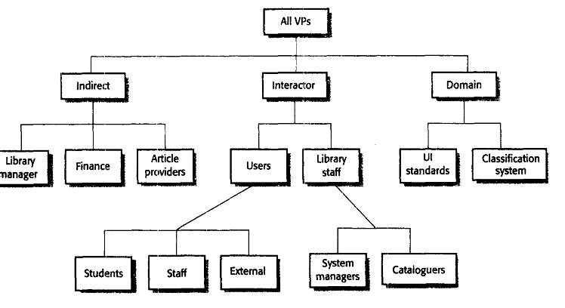
Fig: Viewpoint of LIBSYS
Interviewing
Interviews may be of two types:
1. Closed interviews where the stakeholder answers a predefined set of questions.
2. Open interviews where there is no predefined agenda. The requirements engineering team explores a range of issues with system stakeholders and hence develops a better understanding of their needs.
However, interviews are not so good for understanding the requirements from the application domain.
It is hard to elicit domain knowledge during interviews for two reasons:
1. All application specialists use terminology and jargon that is specific to a domain. It is impossible for them to discuss domain requirements without using this terminology. They normally use terminology in a precise and subtle way that is easy for requirements engineers to misunderstand.
2. Some domain knowledge is so familiar to stakeholders that either they find it difficult to explain or they think it is so fundamental that it is not worth mentioning. For example, for a librarian, it is understood that all acquisitions are catalogued before they are added to the library. However, this may not be obvious to the interviewer so it is not taken into account in the requirements.
Effective interviewers have two characteristics:
- They are open-minded, avoid preconceived ideas about the requirements and are willing to listen to stakeholders. If the stakeholder comes up with surprising requirements, they are willing to change their mind about the system.
- They prompt the interviewee to start discussions with a question.
Scenarios
- Scenarios can be particularly useful for adding detail to an outline requirements description. They are descriptions of example interaction sessions. Each scenario covers one or more possible interactions.
- scenario may include:
I. A description of what the system and users expect when the scenario starts
2. A description of the normal flow of events in the scenario
3, A description of what can go wrong and how this is handled
4. Information about other activities that might be going on at the same time
5. A description of the system state when the scenario finishes.

- Scenarios may be written as text, supplemented by diagrams, screen shots, and so on.
- Simple text scenario, consider how a user of the LIBSYS library system may use the system. This scenario is shown in Figure 7.5.

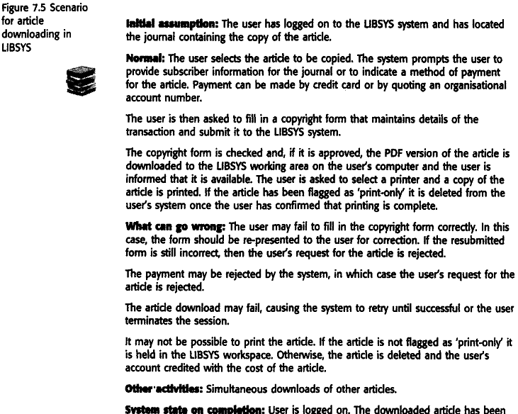
Use-Cases

- Use-cases are a scenario-based technique for requirements elicitation which were first introduced in the Objectory method
- Use-case identifies the type of interaction and the actors involved.
- Use-cases identify the individual interactions with the system.
- Actors in the process are represented as stick figures, and each class of interaction is represented as a named ellipse. The set of use-cases represents all of the possible interactions to be represented in the system requirements.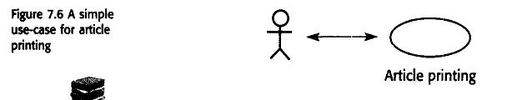
- Figure 7.7 develops the LIBSYS example and shows other use-cases in that environment
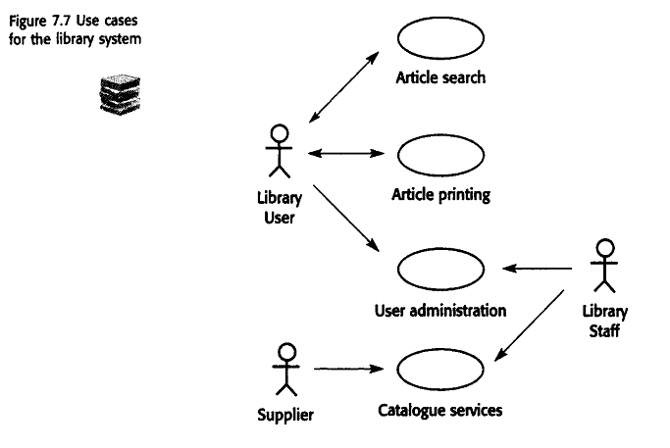
ETHNOGRAPHY
Ethnography is an observational technique that can be used to understand social and organizational requirements. An analyst immerses him or herself in the working environment where the system will be used. He or she observes the day-to-day work and notes made of the actual tasks in which participants are involved.
Ethnography is particularly effective at discovering two types of requirements:
- Requirements that are derived from the way in which people actually work
- Requirements that are derived from cooperation and awareness of other people's activities.
Requirements Validation
Concerned with demonstrating that the requirements define the system that the customer really wants.
  - Requirements error costs are high so validation is very important
- Fixing a requirements error after delivery may cost up to 100 times the cost of fixing an implementation error.
During the requirements validation process, checks should be carried out on the requirements in the requirements document. These checks include:
- Validity. Does the system provide the functions which best support the customer’s needs?
- Consistency. Are there any requirements conflicts?
- Completeness. Are all functions required by the customer included?
- Realism. Can the requirements be implemented given available budget and technology
- Verifiability. Can the requirements be checked?
Reuirements Validation Techniques
  - Requirements reviews Systematic manual analysis of the requirements.
  - Prototyping Using an executable model of the system to check requirements. Covered
  - Test-case generation Developing tests for requirements to check testability.

Requirements reviews
- Regular reviews should be held while the requirements definition is being formulated.
- Both client and contractor staff should be involved in reviews.
- Requirements reviews can be informal or formal.
- Informal reviews simply involve contractors discussing requirements with as many system stakeholders as possible.
- In a formal requirements review, the development team should 'walk' the client through the system requirements, explaining the implications of each requirement.
- Reviewers may also check for:
  - Verifiability. Is the requirement realistically testable?
  - Comprehensibility. Is the requirement properly understood?
  - Traceability. Is the origin of the requirement clearly stated?
  - Adaptability. Can the requirement be changed without a large impact on other requirements?
REQUIREMENTS MANAGEMENT
- The requirements for large software systems are always changing.
- Requirements management is the process of understanding and controlling changes to system requirements. You need to keep track of individual requirements
- Requirements are inevitably incomplete and inconsistent
  - New requirements emerge during the process as business needs change and a better understanding of the system is developed;
  - Different viewpoints have different requirements and these are often contradictory.

Enduring and volatile requirements

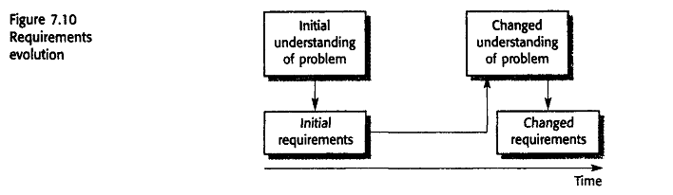

- As the requirements definition is developed, you normally develop a better understanding of users needs.This feeds information back to the user, who may then propose a change to the requirements (Figure 7.10). Furthermore, it may take several years to specify and develop a large system. Over that time, the system's environment and the business objectives may change
- From an evolution perspective, requirements fall into two classes:
- Enduring requirements. Stable requirements derived from the core activity of the customer organisation. E.g. a hospital will always have doctors, nurses, etc. May be derived from domain models
- Volatile requirements. Requirements which change during development or when the system is in use.
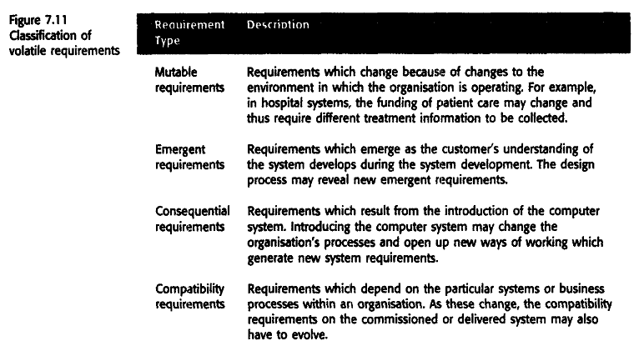

Requirements management planning
Planning is an essential first stage in the requirements management process.Requirements management is very expensive. During the requirements management stage, you have to decide on
Requirements identification: How requirements are uniquely identified;
A change management process: This is the set of activities that assess the impact and cost of changes.
Traceability policies these policies define the relationships between requirements, and between the requirements and the system design that should be recorded and how these records should be maintained
CASE tool support The tool support required to help manage requirements change;
Traceability
Traceability is concerned with the relationships between requirements, their sources and the system design
Source traceabilityLinks from requirements to stakeholders who proposed these requirements;
Requirements traceabilityLinks between dependent requirements; You use this infonnation to assess how many requirements are likely to be affected by a proposed change
Design traceabilityLinks from the requirements to the design; You use this infonnation to assess the impact of proposed requirements changes on the system design and implementation
Traceability information is often represented using traceability matrices
Figure 7.12 shows a simple traceability matrix that records the dependencies between requirements. A 'D' in the row/column intersection illustrates that the requirement in the row depends on the requirement named in the column; an 'R' means that there is some other, weaker relationship between the requirements. For example, they may both define the requirements for parts of the same subsystem.
Traceability matrices can be generated automatically from the database
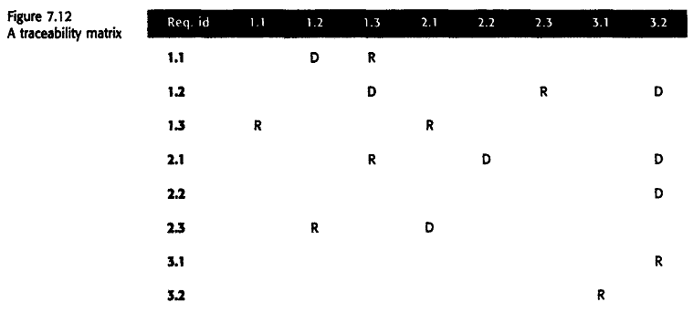
Case Tool Support
Requirements management needs automated support; the CASE tools for this should be chosen during the planning phase. You need tool support for:
Requirements storage The requirements should be maintained in a secure, managed data store that is accessible to everyone involved in the requirements engineering process.
Change management The process of change management (Figure 7.13) is simplified if active tool support is available.
Traceability management As discussed above, tool support for traceability allows related requirements to be discovered.
Requirements Change Management
Requirements change management (Figure 7.13) should be applied to all proposed changes to the requirements. 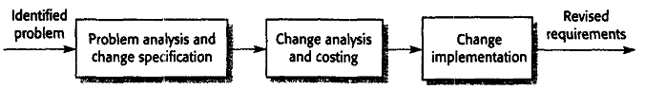
Problem analysis and change specification The process starts with an identified requirements problem or, sometimes, with a specific change proposal. During this stage, the problem or the change proposal is analysed to check that it is valid.
Change analysis and costing The effect of the proposed change is assessed using traceability information and general knowledge of the system requirements.
Change implementation The requirements document and, where necessary, the system design and implementation are modified.

UNIT-III SYSTEM MODELS
- These models are graphical representations that describe business processes, the problem to be solved and the system that is to be developed.
- System modelling helps the analyst to understand the functionality of the system and models are used to communicate with customers.
- Different models present the system from different perspectives
  - External perspective showing the system’s context or environment;
  - Behavioural perspective showing the behaviour of the system;
  - Structural perspective showing the system or data architecture.
- A system model is an abstraction of the system being studied
- Examples of the types of system models that you might create during the analysis
process are:
1. A data- flow model Data-flow models show how data is processed at different
Stages in the system.
2. A composition model A composition or aggregation model shows how entities
in the system are composed of other entities.
3. An architectural model Architectural models show the principal sub-systems
that make up a system.
4. A classification model Object class/inheritance diagrams show how entities have common characteristics.
5. A stimulus-response model A stimulus-response model, or state transition diagram, shows how the system reacts to internal and external events.
Context models
- At an early stage in the requirements elicitation and analysis process we should decide 0n the boundaries of the system. This involves working with system stakeholders to distinguish what is the system and what is the system's environment.
- Social and organisational concerns may affect the decision on where to position system boundaries.
- Once some decisions on the boundaries of the system have been made, part of the analysis activity is the definition of that context and the dependencies that a system has on its environment. Normally, producing a simple architectural model is the first step in this activity
- Architectural models show the system and its relationship with other systems.
- High-level architectural models are usually expressed as simple block diagrams where each sub-system is represented by a named rectangle, and lines indicate associations between sub-systems
- From Figure 8.1, we see that each ATM is connected to an account database, a local branch accounting system, a security system and a system to support machine maintenance. The system is also connected to a usage database that monitors how
the network of ATMs is used and to a local branch counter system. This counter
system provides services such as backup and printing.
- Architectural models describe the environment of a system. However, they do not show the relationships between the other systems in the environment and the system that is being specified. External systems might produce data for or consume data from the system.

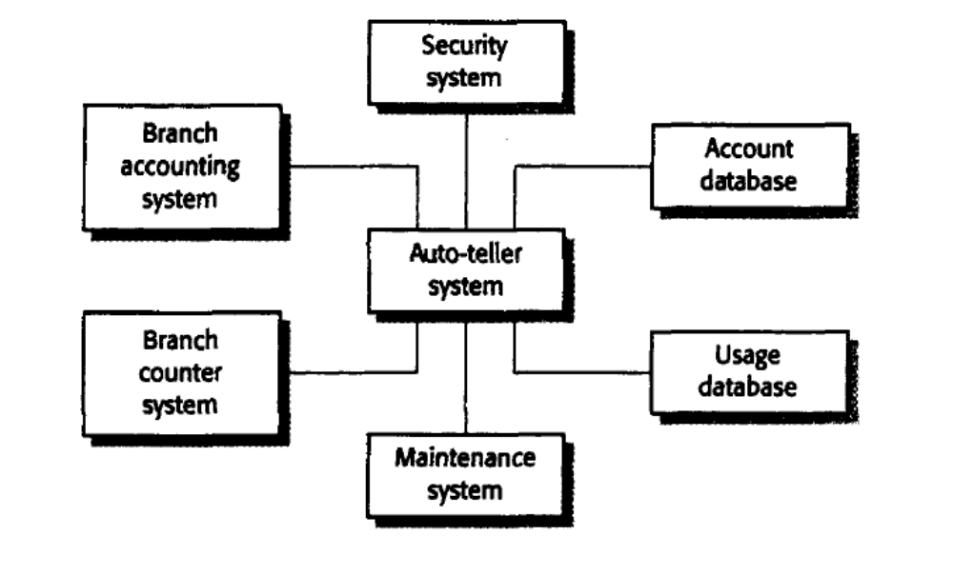
Fig: 8.1 Architectural model of an ATM

- Simple architectural models are normally supplemented by other models, such as process models, that show the process activities supported by the system.
- Data-flow models may also be used to show the data that is transferred between the system and other systems in its environment.

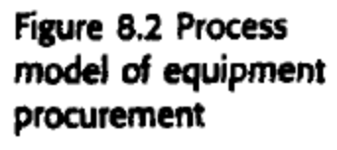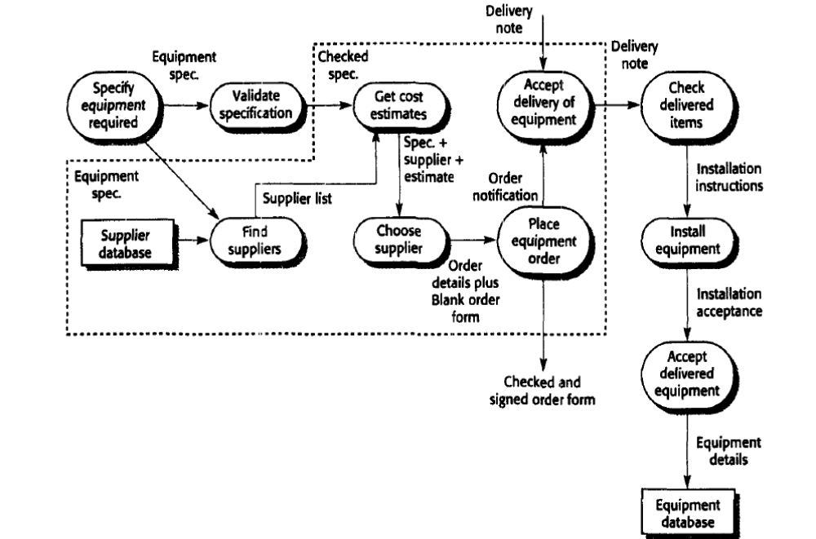
Figure 8.2 illustrates a process model for the process of procuring equipment in an organization. This involves specifying the equipment required, finding and choosing suppliers, ordering the equipment, taking delivery of the equipment and testing it after delivery. When specifying computer support for this process, we have to decide which of these activities will actually be supported. The other activities are outside the boundary of the system. In Figure 8.2, the dotted line encloses the activities that are within the system boundary.

Behavioural models

Behavioural models are used to describe the overall behaviour of a system.

Two types of behavioural model are:
  - Data processing models that show how data is processed as it moves through the system;
  - State machine models that show the systems response to events
Data flow models
- Data flow diagrams (DFDs) may be used to model the system’s data processing.
- These show the processing steps as data flows through a system.
- DFDs are an intrinsic part of many analysis methods.
- Simple and intuitive notation that customers can understand.
- The notation used in these models represents functional processing (rounded rectangles), data stores (rectangles) and data movementsbetween functions (labelled arrows).
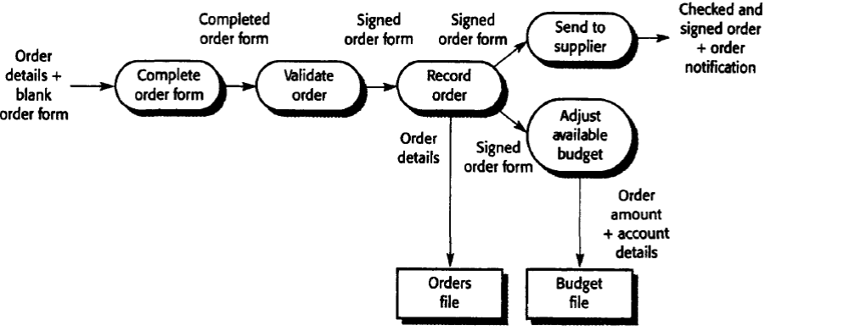
Fig:8.3 Data flow diagram of order processing
A data-flow model, which shows the steps involved in processing an order for goods (such as computer equipment) in an organization, is illustrated in Figure 8.3.This particular model describes the data processing in the Place equipment order activity in the overall process model shown in Figure 8.2. The model shows how the order for the goods moves from process to process. It also shows the data stores (Orders file and Budget file) that are involved in this process.
- Data-flow models are valuable because tracking and documenting how the data associated with a particular process moves through the system helps analysts understand what is going on
- Data-flow models show a functional perspective where each transformation represents a single function or process. They are particularly useful during the analysis of requirements
- That is, they show the entire sequence of actions that take place from an input being
processed to the corresponding output that is the system's response. Figure 8.4 illustrates this use of data flow diagrams.
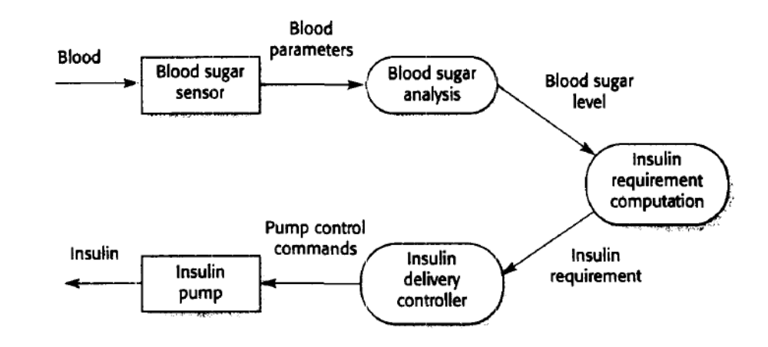
Fig:8.4 DFD for insulin pump
State-Machine models
These model the behaviour of the system in response to external and internal events.
They show the system’s responses to stimuli so are often used for modelling real-time systems.
State machine models show system states as nodes and events as arcs between these odes. When an event occurs, the system moves from one state to another.
Statecharts are an integral part of the UML and are used to represent state machine models
State-charts allow the decomposition of a model into sub-models.A brief description of the actions is included following the ‘do’ in each state.
This approach to system modelling is illustrated in Figure 8.5. This diagram shows a state machine model of a simple microwave oven equipped with buttons to set the power and the timer and to start the system.
sequence of actions in using the microwave is:
1. Select the power level (either half-power or full-power).
2. Input the cooking time.
3. Press Start, and the food is cooked for the given time.
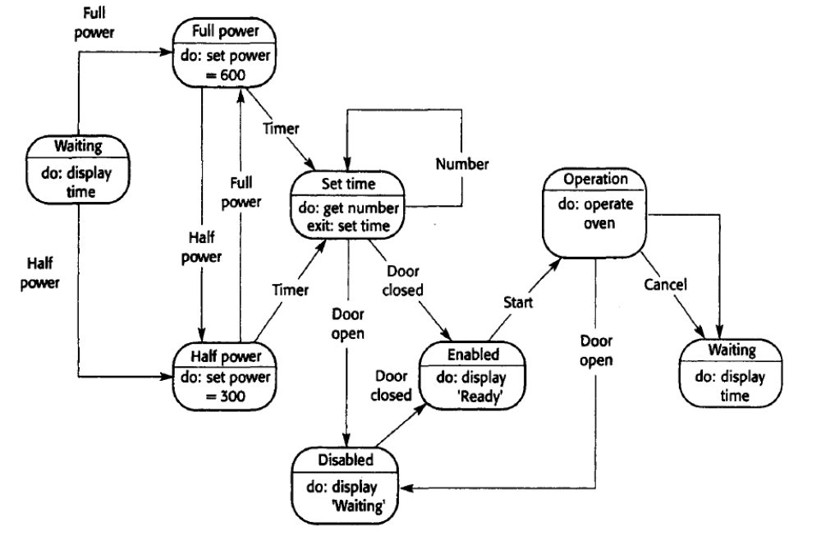
Fig:8.5 State-Machine Model Of a MicroWave Oven
For safety reasons, the oven should not operate when the door is open and, on completion of cooking, a buzzer is sounded. we can see that the system responds initially to either the full-power or the half-power button. Users can change their mind after selecting one of these and press the other button. The time is set and, if the door is closed,the Start button is enabled. Pushing this button starts the oven operation and cooking takes place for the specified time.
- In a detailed system specification, you have to provide more detail about both the stimuli
and the system states (Figure 8.6). This information may be maintained in a data dictionary or encyclopaedia .

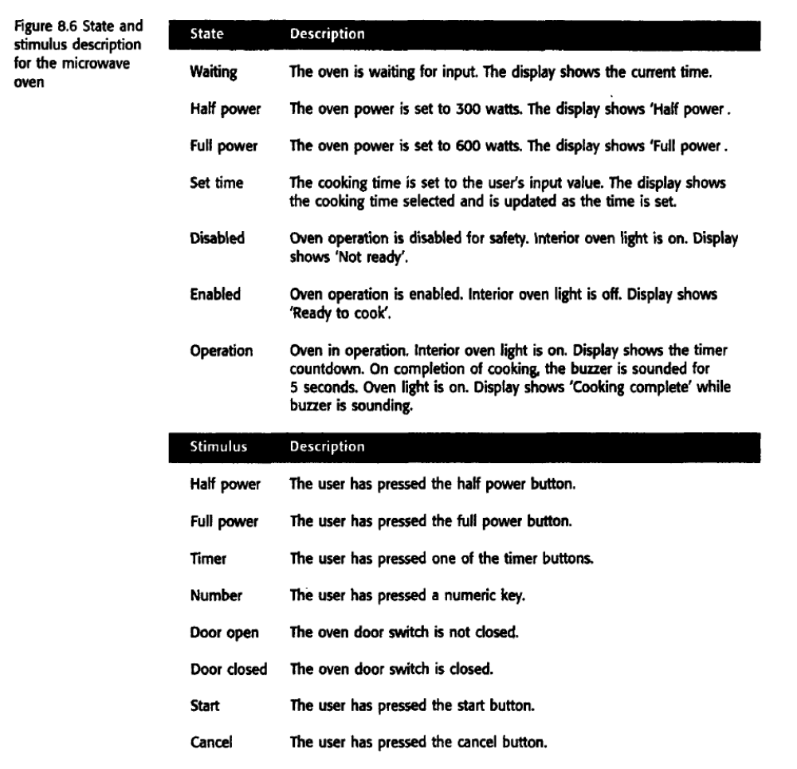
- The problem with the state machine approach is that the number of possible states increases rapidly. For large system models, therefore, some structuring of these state models is necessary. One way to do this is by using the notion of a superstate that encapsulates a number of separate states. This superstate looks like a single state on a high-level model but is then expanded in more detail on a separate diagram.To illustrate this concept, consider the Operation state in Figure 8.5. This is a superstate that can be expanded, as illustrated in Fig 8.7.

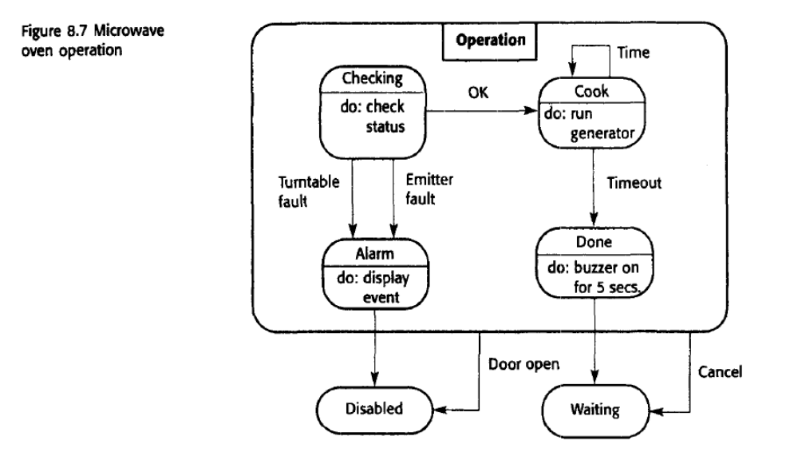
- The Operation state includes a number of sub-states. It shows that operation starts with a status check, and that if any problems are discovered, an alarm is indicated and operation is disabled. Cooking involves running the microwave generator for the specified time; on completion, a buzzer is sounded. If the door is opened during operation, the system moves to the disabled state

Semantic data models

  - Used to describe the logical structure of data processed by the system. These are sometimes called semantic data models.
  - An entity-relation-attribute model sets out the entities in the system, the relationships between these entities and the entity attributes
  - Widely used in database design. Can readily be implemented using relational databases.
  - No specific notation provided in the UML but objects and associations can be used.
  - Figure 8.8 is an example of a data model that is part of the library system LIBSYS introduced in earlier chapters. Recall that LIBSYS is designed to deliver copies of copyrighted articles that have been published in magazines and journals and to collect payments for these articles. Therefore, the data model must include information about the article, the copyright holder and the buyer of the article. I have assumed that payments for articles are not made directly but through national copyright agencies.
  - Figure 8.8 shows that an Article has attributes representing the title, the authors,the name of the PDF file of the article and the fee payable. This is linked to the Source, where the article was published, and to the Copyright Agency for the country of publication. Both Copyright Agency and Source are linked to Country. The country of publication is important because copyright laws vary by country. The diagram also shows that Buyers place Orders for Articles.

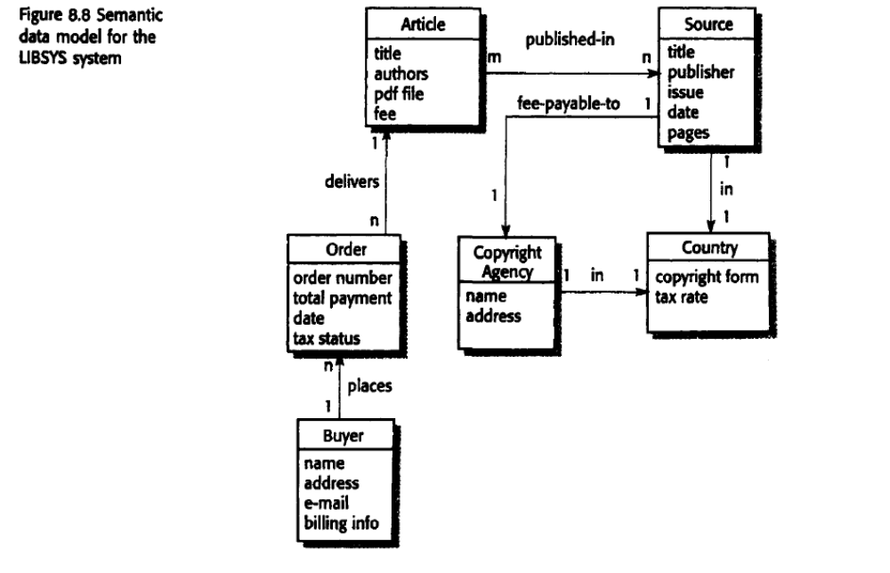

- Like all graphical models, data models lack detail, and you should maintain more detailed descriptions of the entities, relationships and attributes that are included in the model. We may collect these more detailed descriptions in a repository or data dictionary.

- Data dictionaries are generally useful when developing system models
- They may be used to manage all information from all types of system models.
- A data dictionary is. simplistically, an alphabetic list of the names included in the system models. As well as the name, the dictionary should include an associated description of the named entity and, if the name represents a composite object,a description of the composition. Other information such as the date of creation.the creator and the representation of the entity may also be included depending on the type of model being developed.
- The advantages of using a data dictionary are:
- 1. It is a mechanism for name management. Many people may have to invent names
for entities and relationships when developing a large system model. These names should be used consistently and should not clash. The data dictionary software can check for ame uniqueness where necessary and warn requirements analysts of name duplications.

- 2. It serves as a store of organisational information. As the system is developed,information that can link analysis, design, implementation and evolution is added to the data dictionary, so that all information about an entity is in one place.

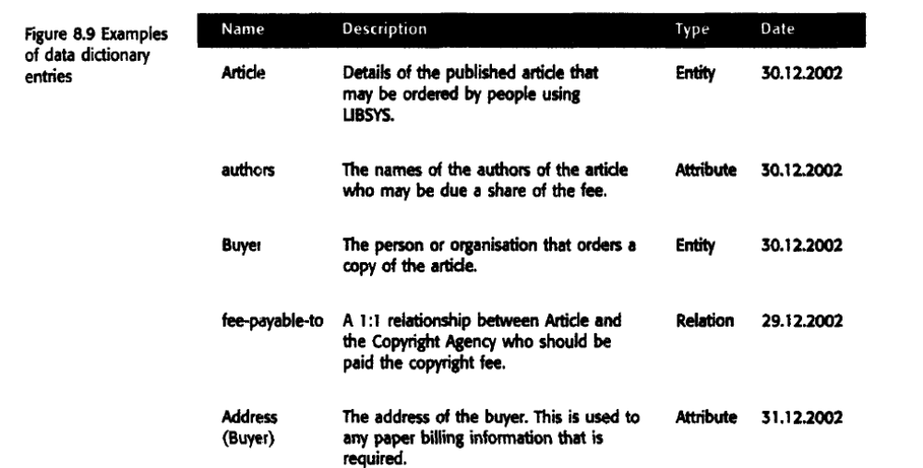
Object models

- Object models describe the system in terms of object classes and their ssociations.
- An object class is an abstraction over a set of objects with common attributes and the services (operations) provided by each object.
- Objects are executable entities with the attributes and services of the object class. Objects are instantiations of the object class, and many objects may be created from a class.
- In object-oriented requirements analysis, we should model real-world entities
using object classes.
- Various object models may be produced
      - Inheritance models;
      - Aggregation models;
      - Interaction models.
- An object class in UML, as illustrated in the examples in Figure 8.10, is represented as a vertically oriented rectangle with three sections:
I. The name of the object class is in the top section.
2. The class attributes are in the middle section.
3. The operations associated with the object class are in the lower section of the rectangle.

- Object class identification is recognised as a difficult process requiring a deep understanding of the application domain

Inheritance Models

Object-oriented modelling involves identifying the classes of object that are important in the domain being studied. These are then organised into a taxonomy. A taxonomy is a classification scheme that shows how all object class is related to other classes through common attributes and services.

the classes are organised into an inheritance hierarchy with the most general object classes at the top of the hierarchy. More specialized objects inherit their attributes and services. These specialized objects may have their own attributes and services.

- Figure 8.10 illustrates part of a simplified class hierarchy for a model of a library.
- This hierarchy gives information about the items held in the library. The library
holds various items, such as books, music, recordings of films, magazines and newspapers. In Figure 8.10, the most general item is at at the top of the tree and has a set of attributes and services that are common to all library items. These are inherited by the classes Published item and Recorded item, which add their own attributes that are then inherited by lower-level items.

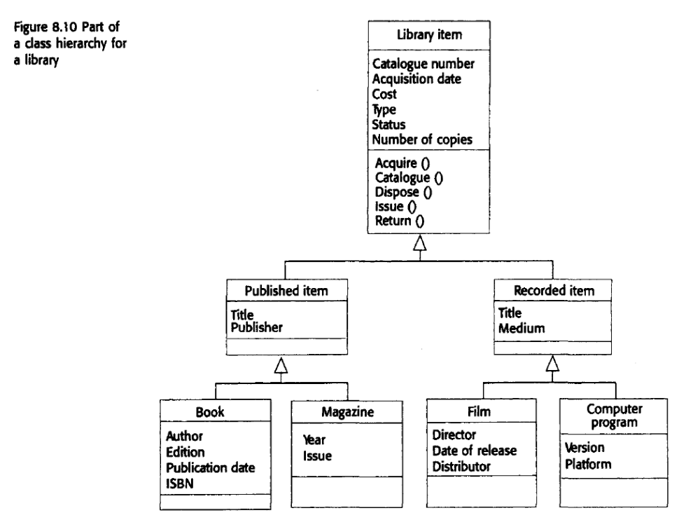
Multiple inheritance models may also be constructed where a class has several parents. Its inherited attributes and services are a conjunction of those inherited from each super-class. Figure 8.12 shows an example of a multiple inheritance model that may also be part of the library model.
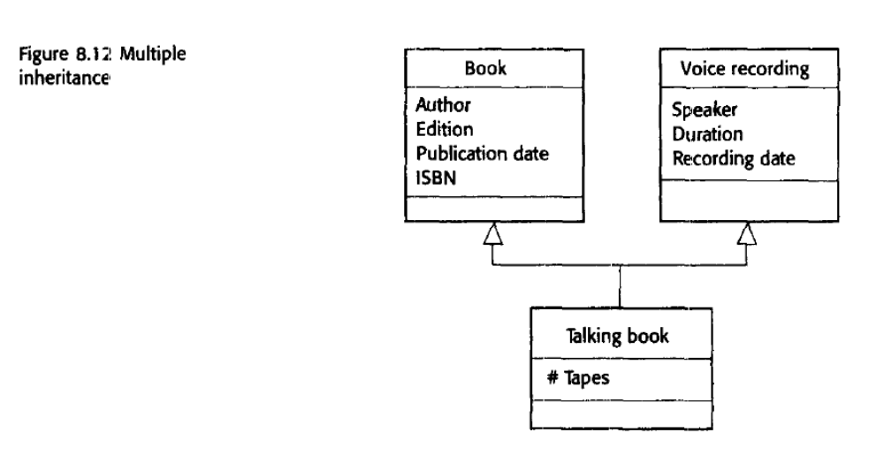
Object aggregation
- An aggregation model shows how classes that are collections are composed of other classes.
- Aggregation models are similar to the part-of relationship in semantic data models.
- in Figure 8.13. I have modelled a library item, which is a study pack for a university course. This study pack includes lecture notes, exercises, sample solutions, copies of transparencies used in lectures, and videotapes.
- The UML notation for aggregation is to represent the composition by including a diamond shape on the source of the link. Therefore, Figure 8.13 can be read as 'A study pack is composed of one of more assignments, OHP slide packages, lecture notes and videotapes
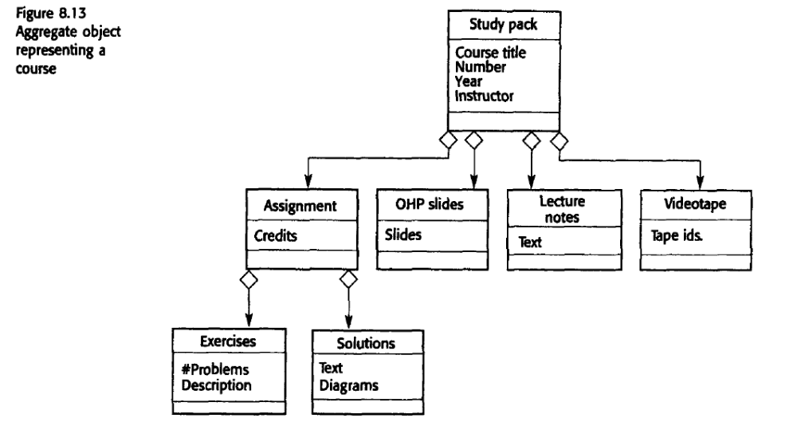
Object behaviour modelling
- To model the behaviour of objects, you have to show how the operations provided by the objects are used. In the UML, you model behaviours using scenarios that are represented as UML use-cases
- Sequence diagrams (or collaboration diagrams) in the UML are used to model interaction between objects.
- For example, imagine a situation where the study packs shown in Figure 8.13 could be maintained electronically and downloaded to the student's computer.
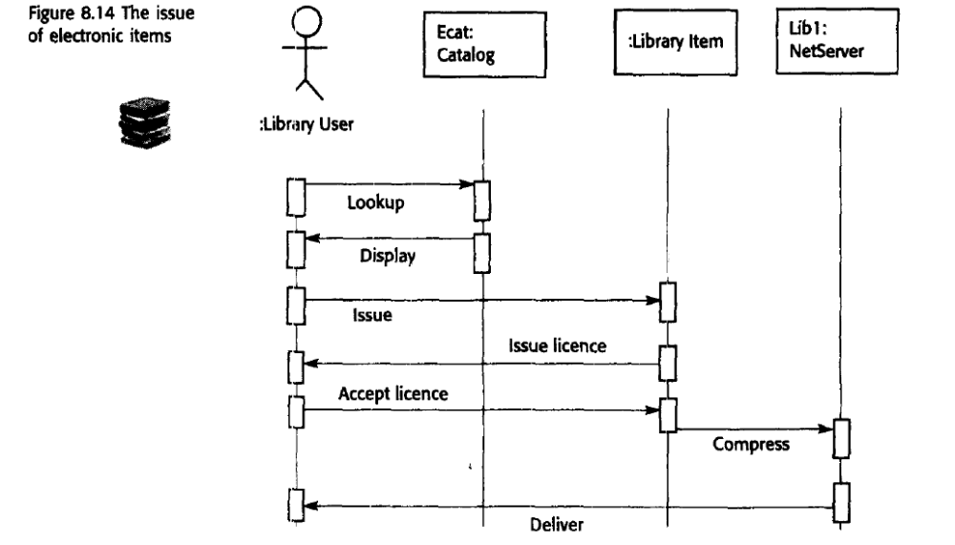

In a sequence diagram, objects and actors are aligned along the top of the diagram.Labelled arrows indicate operations; the sequence of operations is from top to bottom. In this scenario, the library user accesses the catalogue to see whether the item required is available electronically; if it is, the user requests the electronic issue of that item. For copyright reasons, this must be licensed so there is a transaction between the item and the user where the license is agreed. The item to be issued is then sent to a network server object for compression before being sent to the library user.

Structured methods
- A structured method is a systematic way of producing models of an existing system or of a system that is to be built. They were first developed in the 1970s to support software analysis and design
- Methods define a set of models, a process for deriving these models and rules and guidelines that should apply to the models.
- CASE tools support system modelling as part of a structured method.
- Structured methods have been applied successfully in many large projects. However, structured methods suffer from a number of weaknesses:
  - They do not model non-functional system requirements.
  - They do not usually include information about whether a method is appropriate for a given problem.
  - They may produce too much documentation.
  - The system models are sometimes too detailed and difficult for users to understand
- A coherent set of tools that is designed to support related software process activities such as analysis, design or testing.
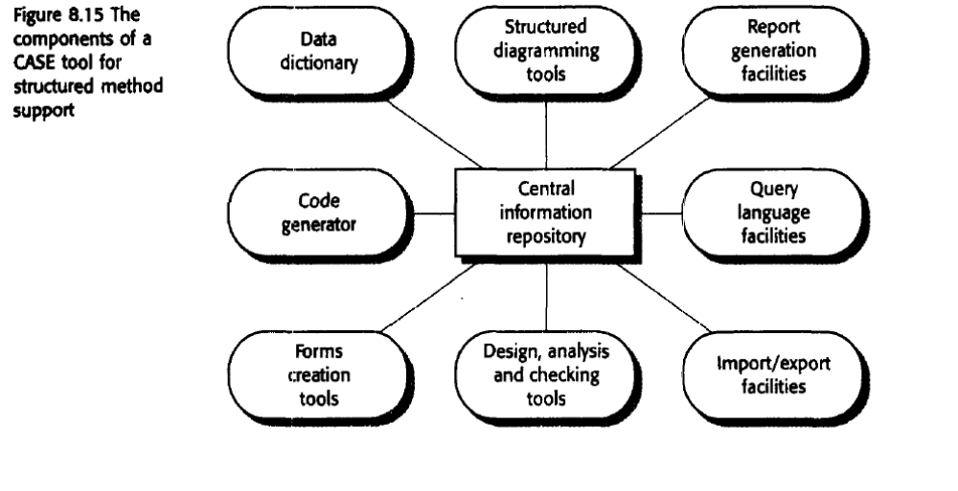
1. Diagram editors used to create object models, data models, behavioural models,and so on. These editors are not just drawing tools but are aware of the types of entities in the diagram. They capture information about these entities and save this information in the central repository.
2. DeSign analysis and checking tools that process; the design and report on error and anomalies. These may be integrated with the editing system so that user errors are trapped at an early stage in the process.
3. Repository query languages that allow the designer to find designs and associated design information in the repository.
4. A data dictionary that maintains information about the entities used in a system design.
5. Report definition and generation tools that take information from the central store and automatically generate system documentation.
6. Forms definition tools that allow screen and document formats to be specified.
7. Import/export facilities that allow the interchange of information from the central repository with other development tools.
8. Code generators that generate code or code skeletons automatically from the design captured in the central store.

